Abstract Title

Deqing Kong ¹, Shinya Kumagai ², and Minoru Sasaki ¹
¹Toyota Technological Institute,
2-12-1 Hisakata, Tempaku-ku, Nagoya 468-8511, JAPAN
²Meijo University,
1-501 Shiogamaguchi, Tempaku-ku, Nagoya 468-8502, JAPAN

Abstract

The 12th International Conference on BioSensors, BioElectronics, BioMedical Devices, BioMEMS/NEMS & Applications (Bio4Apps 2026) will be held Novemnber 5-7, 2026 in Toyota Technological Institute, Nagoya, Japan. Authors are invited to contribute your work for either oral or poster presentation. Please submit your abstract in MS WORD (*.doc) or PDF files ^{[1]}.

As the conference abstracts will be published in A4 format, it seems advisable to set up the layout on your PC/Mac/workstation in this format. A4 paper is 29.7 cm high and 21 cm wide (or 8.27 inches x 11.69 inches). In this format, define 1.5 cm (.60 inches) wide left and right margins, a 2.5 cm high top margin (1 inch) and a 3 cm (1.20 inches) bottom margin. The title/author/affiliation section should be centered above both columns.

Please use Times New Roman throughout the entire manuscript, from title, authors, affiliation, and headers, to figure and table captions, and references. The length of the abstract, including reference and author biography, can vary from 1 to 2 pages. To achieve as unified a look across the abstracts as possible, the following formats are preferred for the main paragraph types, as illustrated also by this sample manuscript:
• Title: 16 points, bold;
• Authors: 12 points, bold italic;
• Affiliation: 12 points, regular;
• Street, City, STATE/Province,
COUNTRY: 12 points, regular
• Text body: 12 points, regular;
• Figure captions: 10 points, italic;
• Table captions: 10 points, italic;
• The font size of references is 10 points, regular, numbered in [ ].
Each figure should be accompanied by a numbered caption, as shown in Figure 1, placed directly below the figure being described. All labels within the figure frame should be in font 9 points or larger.

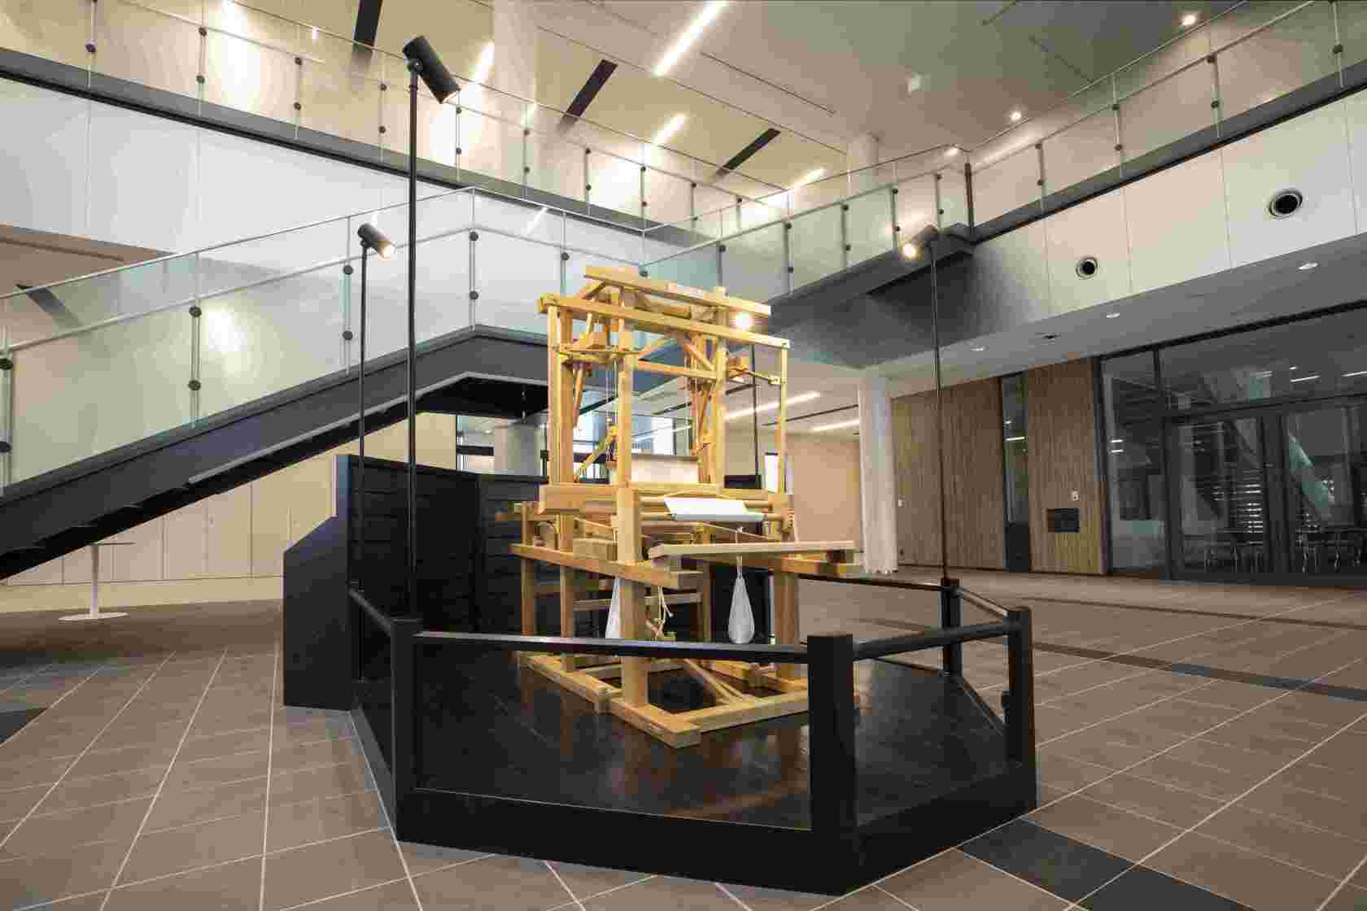
Figure 1. Toyoda Wooden Hand Loom (Sakichi Toyoda's first invention)

Table 1. Sample of a Table Format
Table Head | Table Column Head
Table Head | Table Column Subhead | Subhead | Subhead
Copy | More table copy

Tables should be preceded by a caption. Table 1 illustrates a possible design with 12 points font size.

Reference

[1] K. Noda, T. Tsukagoshi, M. Takeda, and I. Shimoyama “Abstract Title”, Abstract Template of Bio4Apps 2024., Vol. **, **-** (2024).
[2] H. Liu and C. Lee “Abstract Title”, Abstract Template of Bio4Apps 2025., Vol. **, **-** (2025).

Author biography

The presenting author (typically the first author) is encouraged to provide a short biography (approximately 100 to 200 words.) There is no need to provide author’s photograph.

